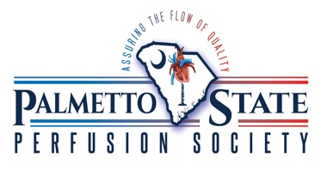
Palmetto State Perfusion Society
&
Perfusion Life
2020 Carolina Perfusion Symposium
Abstract Submission Form

Due: April 1st, 2020

Instructions:
The PSPS Board will evaluate all proposals submitted by the deadline. Proposals will be evaluated in two ways:
- Merit and clarity of the 300-word abstract
- Concisely state the objectives of the study. Abstracts should contain subheadings as follows: Background, Methods, Results, and Conclusion.
- Completeness of the proposal, particularly having well-developed content to understand all relevant aspects of the topic.
- Abstract authors may submit their abstract for consideration as a poster, an oral presentation, or for both.
- Follow the following abstract format:

Abstract Format:
Name:
Institution or Affiliation:
Student or CCP:
Type of submission: Oral Presentation, Poster, or both
Professional contact email: (this email will be posted on the meeting agenda)
Abstract:

Individuals with proposals chosen for inclusion in the July 17th Carolina Perfusion Symposium will be notified by April 30th, 2020.
Please submit all submission forms to: PalmettoPerfusion@gmail.com
Any questions, please contact Dafne Chianella: chiarel@musc.edu

